Uncontrolled copy not subject to amendment

Air Cadet Publication (ACP) 1

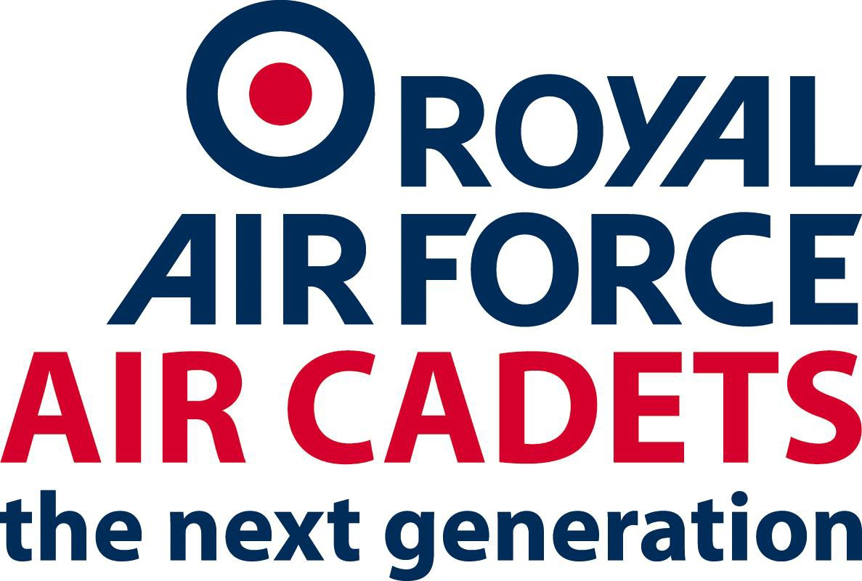

Ethos, Core Values
and Standards in the Royal Air Force Air Cadets Organisation

SO2 Personnel September 2020

Amendment sheet

Date | Amendment | Amended by | Version no
16/11/2017 | Insert Front Cover and Amendment Sheet | J Stones | 5.00
08/01/2019 | Add new version tag following migration to SPOL no actual change to the document. | M Pratley | 6.00
08/01/2019 | Add new version tag following migration to SPOL no actual change to the document. | M Pratley | 7.00
09/01/2019 | Update Label | J Stones | 8.00
15/05/2019 | Update Links | J Stones | 9.00
28/09/2020 | Update to reflect changes to AP1 | Sqn Ldr Heath | 10.0

Ethos, Core Values and Standards in the
Royal Air Force Air Cadets

Foreword – by the Commandant RAF Air Cadets

As Commandant, I have the honour and responsibility of leading the Royal Air Force Air Cadets (RAFAC) which provides challenging activities to enable it to attract and retain membership and thereby provide examples of good behaviour and leadership for today’s youth. The RAFAC’s mission is to be the modern, dynamic, sustainable air-minded youth organisation of choice that offers fun and challenging opportunities for both cadets and volunteers.

As the uniformed youth service parented by the Royal Air Force, the RAFAC has the following aims:

- to promote and encourage among young people a practical interest in aviation and the RAF;
- to provide training which will be useful both in Service and civilian life;
- to foster the spirit of adventure; and
- to develop the qualities of citizenship and leadership.

The RAFAC has a proud tradition and a reputation for excellence. To maintain and enhance that reputation we must respect and properly recognise the value of all volunteers and cadets who serve in, or who support, the RAFAC.

This booklet sets out the Ethos, Core Values and Standards which we must all uphold as members of the RAFAC. These values and standards are not only the foundation of mutual trust and respect within the RAFAC, they are also central to our ability to work together with other uniformed youth services, the regular Services and with everyone else who supports us in our endeavours. Please read this booklet carefully. If in doubt, always remember that your values and behaviour reflect not only your own personal approach to life, but also how our organisation is seen by others.

The Ethos, Core Values and Standards of the Air Training Corps

The Ethos of the RAF Air Cadets (RAFAC)

“The Ethos of the RAFAC is made up of the distinctive character, spirit and attitudes which together inspire young people to pursue the spirit of adventure”.

The RAFAC needs individuals who will respond to a demanding challenge, who aspire to the required standards of excellence, who share a sense of commitment and who understand our core values. We want people who are proud to develop the youth of the country and whose personal qualities reflect the values required by the RAFAC. The success of the RAFAC in any endeavour is dependent upon the willingness of its volunteers to wholeheartedly support its aims. This commitment grows from a desire to help challenge young people in order to mould the ambitions of the next generation.

The Core Values of the RAFAC

The RAFAC Core Values are the beliefs and principles that define who we are. Our Core Values are:

R – Respect
I – Integrity
S – Service
E – Excellence

These values help to unify the RAFAC and are the bedrock of our Ethos for proving a modern, dynamic, sustainable air-minded youth organisation of choice.

Respect

Respect comprises:

Self-Respect.

People who encourage an environment of high personal standards, teamwork and professionalism are key to nurturing self-respect in those around them. People with self-respect have high personal standards and behave in ways that bring credit to themselves, their team and the RAFAC.

Mutual Respect.

Respect for others is essential – up and down the chain of command amongst peers (both uniformed and non-uniformed volunteers), cadets, and the wider society. The close-knit RAFAC family is richly diverse, and we must value and respect everyone, regardless of their race, religion, gender, sexual orientation, social background or any other characteristic. Some of these characteristics are protected by law, but true respect goes beyond legal requirements, and RAFAC volunteers and cadets must always maintain the highest of standards of decency and justice towards people, whatever the circumstances.

Humility

Irrespective of your position or rank, every person you engage with has the right to be treated as an equal. All RAFAC volunteers and cadets should aim to be modest, genuine and reasonable with others, respecting their right to hold different views and opinions.

Inclusion

In RAFAC, total inclusivity is not negotiable; it is critical to team cohesion and our success. Each one of us has a responsibility to ensure the people around us always feel welcome and included.

Integrity

Integrity is about being honest and having strong moral principles. It is the basis for trust and reflects the key principles of moral courage, honesty and justice:

Moral Courage

Moral courage is about doing the right thing, even though it may be unpopular and the personal cost may be high. Maintaining personal values and the highest standards of decency and behaviour in the face of opposition earns the respect of others and builds trust.

Honesty

Honesty is integral to the RAFAC and our word must never be in doubt. Dishonesty or breaches of trust show a lack integrity and call into question an individual’s reliability. Dishonesty damages trust and team cohesion, and impacts upon the effectiveness of the organisation.

Justice

A person with integrity routinely demonstrates balanced and consistent behaviour and treatment. It is vital that everyone in the RAFAC is treated fairly and consistently and that justice is done – and seen to be done – without prejudice or favour.

Service

Service is an act of unselfish commitment with a willingness to put other people before ourselves. Service incorporates the values of physical and mental courage, loyalty, commitment and teamwork.

Physical and Mental Courage

Courage, both physical and mental, is the cornerstone upon which success depends. It underpins the spirit and determination needed to deliver a leading air-minded youth experience that offers challenging opportunities, for both cadets and volunteers.

Loyalty

From the moment we join the organisation, we are each committed to uphold and preserve the values of the RAFAC. Loyalty works at all levels and those who are placed in positions of authority must be loyal to their team, representing their interests, dealing with complaints thoroughly, and developing their abilities through progressive training. Team members must be loyal to their leaders and their colleagues.

Commitment

Commitment works in two ways: the commitment of individuals to RAFAC and, in return, commitment from the organisation to the individual. For individuals, this commitment may be reflected in the award of an appointment in the RAFAC, be that as a volunteer or as a Staff Cadet or cadet NCO. When on RAFAC duty it imposes limitations on individual freedom and it might require a degree of self-sacrifice. For those in authority, it requires them to discharge their responsibilities and their duty of care to their teams and, more importantly, the cadets in their charge.

Teamwork

Teamwork is essential if we are to sustain a vibrant and effective RAFAC in an ever-changing society. It is about working together with each member of our organisation and with the other uniformed youth services, where all personnel have a voice and feel valued, which is the foundation for genuine inclusion. Teamwork relies on team members treating all others with respect.

Excellence

By striving for excellence we drive for the continuous improvement and innovation which will ensure that the RAFAC remains second to none in providing a challenging and demanding environment. Our cadets can then mature and develop into well rounded individuals protected by our Duty of Care. Key qualities include:

Personal Excellence

Every member of the RAFAC has a personal responsibility to achieve and maintain the highest personal standards, thereby enhancing the competence, cohesion and reputation of the RAFAC.

Discipline

The most effective discipline is self-discipline, which comes from within and is not imposed. Good discipline enables us to achieve more than we would normally expect of ourselves. Discipline must be rigorously but fairly upheld by everyone in positions of authority, and all RAFAC members must display high levels of self-discipline – both on and off duty.

Pride

We must be proud of our expertise and that we are second to none in delivery of the cadet experience.

Leadership
Though not a core value itself, leadership is at the heart of an effective and thriving RAFAC. Good leadership inspires, underpins and enables all our qualities, values and capabilities. It can transcend limited resources and overcome the greatest of difficulties. It is not solely the preserve of command; every member of the RAFAC has the capacity for leadership. It is an innate quality, honed and developed by training, experience and hard work. The best leadership is leadership by example:

Albert Einstein – “Setting an example is not the main means of influencing another, it is the only way”.

The Standards of the RAFAC

The RAFAC family is rich in diversity and culture, and it is important that we value and respect everyone, regardless of their background. We are held in high regard and have an enviable reputation; we should all be justifiably proud of this hard-earned reputation, which we have a duty to maintain. We can do this through individual excellence, great teamwork, continued success and effective leadership – but it can only flourish in an environment of mutual respect and trust. Trust is earned by demonstrating both professional competence and personal integrity. In turn, personal integrity is assured by the self-discipline that comes from doing the right thing, even when no-one is looking. Positive behaviours engender trust and enhance our reputation, and they create team spirit and underpin our ability to meet our objectives.

All RAFAC members have a duty to tackle inappropriate behaviour – whether
physical, verbal or on social media – and not turn a blind eye. Examples of inappropriate behaviour include, but are not limited to:

- breaching laws, norms of behaviour, or core values and standards;
- bullying;
- harassment;
- discrimination;
- unwelcome sexual attention;
- taking advantage of, or mistreating, others;
- drug or alcohol misuse; and
- inappropriate use of social media.

Rules and regulations for these behaviours are contained within other Air Cadet publications.

Wing, Squadron and Unit Commanders have the added responsibility of supervising their adult volunteers and making them aware of any failings that need to be corrected. Where their advice is ignored or serious misconduct or indiscipline has occurred, commanders must immediately take appropriate action in accordance with RAFAC rules, Service regulations and instructions.

Whether on or off duty, members of the RAFAC family must not ignore inappropriate behaviours or be a ‘passive bystander’. We must instead demonstrate our values and standards out of respect for others and for the good of our reputation, and because our ethos demands it. Every leader across the RAFAC must promote a culture where we drive out inappropriate behaviours – aiming to stop instances of them occurring but dealing with them effectively if they do. Leaders must set the example and the standards, and ensure that their people meet those standards consistently. But upholding our values and standards is not just the responsibility of leaders – it is the personal responsibility of every member of the RAFAC.

The success and good name of the RAFAC depends very heavily upon the commitment and conduct of each and every adult volunteer. There are two key aspects: the correct approach to the discharge of all responsibilities, and the highest level of personal conduct both on and off duty. When fulfilling their responsibilities, all volunteers – CFC / RAFVR(T) officers, Warrant Officers (W O (ATC)), Senior Non-Commissioned Officers (SNCO (ATC)), Civilian Instructors (CI), and Civilian Committee Members – should adhere to and set the highest standards. They should meet their obligations as volunteers by ensuring that all RAFAC training and activities are efficiently, safely and imaginatively delivered. All of the training provided by the RAFAC is designed to challenge cadets and, as appropriate, to develop their natural instinct for adventure within the safest possible environment. It is therefore vital that all volunteers exercise, with vigilance, their legal Duty of Care responsibilities for the cadets in their charge (see ACP 4 – Safeguarding and Protecting Children – for further details).

A broad variety of personal conduct and behaviour may be regarded as acceptable in society at large. However, adult volunteer service brings with it an obligation, both on and off duty, to demonstrate the highest standards of social and moral conduct. Officers and WOs/SNCOs (ATC) frequently wear uniform in public and, as members of their local communities, even when not in uniform, are usually known to be commissioned or hold WO (ATC) or SNCO (ATC) rank. Their social and moral conduct is therefore judged by the public in the context of their uniformed roles. Uniformed volunteers also have more frequent and widespread contact with the public than do Regular Armed Forces personnel, and they must always be aware that they play a very significant role in determining how society judges the Royal Air Force as a whole.
Any misconduct, whether in sexual matters or in general social behaviour, is totally inappropriate for those who wish to make a positive contribution to the development of the Nation’s youth. This includes inappropriate behaviour on the part of an adult volunteer, particularly if occurring between adult staff and cadets of any age and would be regarded as extremely serious. If such misconduct suggests that a volunteer is unable to fulfil their obligations to the cadets in their charge, they will have to leave the RAFAC. Adult volunteers who find themselves in an actual or potential situation that could cause embarrassment to others or to the RAFAC, must report the fact immediately.

Caring for Young People and the Vulnerable

All organisations involved with caring for young people should, through Principles of Good Practice have Codes of Conduct to protect against sexual activity occurring within relationships of trust. ACP 4 outlines the Principles of Good Practice and through its Code of Conduct amplifies who is protected and how. It must be clearly understood that every adult supervisor in the RAFAC has a personal responsibility for the safety and welfare of cadets. This applies not only to cadets under their immediate command, but generally. The safety and welfare of cadets overrides any other consideration.

A Final Thought
The success of a modern and progressive RAFAC must continue to be founded on a binding Ethos underpinned by the Core Values of Respect, Integrity, Service and Excellence. Teamwork, success and effective leadership flourish in an environment of mutual trust and respect. In this context, we all have a responsibility to our colleagues, be they leaders or team members, to do our best to uphold our Ethos and embrace our Core Values. Behaviour or conduct which undermines trust, creates division, or which draws into question the good name of the RAFAC must not be tolerated: we should take pride in our traditions and we should do all we can to sustain the values which characterise RAFAC life. This is a reflection of our unique role in helping to prepare the young people of the country to take and accept their role as positive and active citizens in society at large. In doing so, they will be our most effective ambassadors.

This publication does not discriminate on grounds of race, ethnic origin, religion, sexual orientation or social background. Neither does it discriminate on grounds of gender, disability or age, insofar as the legislation applies to the RAFAC. This document is sponsored by COS RAFAC.

